

Istanbul Technical University

Department of Computer Engineering

BLG 202E – Numerical Methods

Assignment 2

Solutions

**Solution 1**

syms x

x0 = 2; %%Initial x

xn = 0; %%Next value of x

i = 0; %%Iteration step

err = 1; %% Absolute relative approximate error

fprintf('Initial x = %f\n', x0)

while i < 15

f = inline(10/(x^3-1), 'x'); %%g(x)

xn = f(x0); %%Fixed Point Iteration

err = (xn-x0)/xn*100;

x0 = xn;

i = i +1;

fprintf('Iteration %d: x = %.20f, err = %.20f\n', i, xn, err)

end

Above Matlab Code is an example of fixed point iterative method which iterate fifteen times. In 8th lines, definition of $g\left(x\right)$ is updated for each given $g\left(x\right)$.

**Solution 1.a**

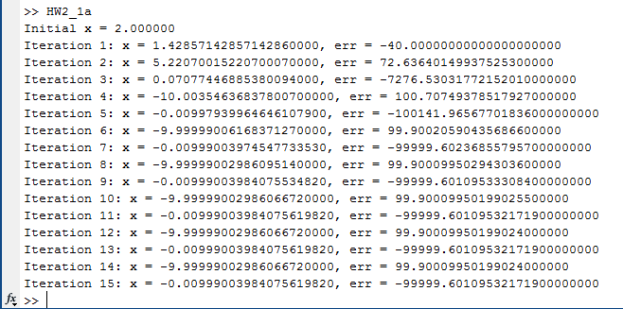

For $g_{1}\left(x\right)= \frac{10}{x^{3}-1}$, equation does not give a root.

**Solution 1.b**

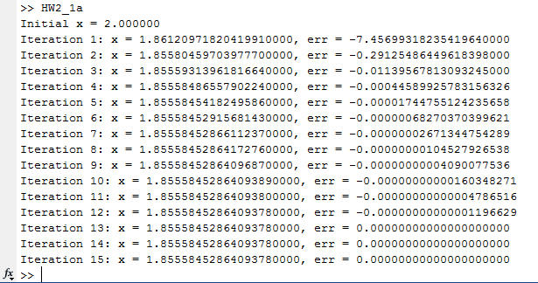

For $g_{2}\left(x\right)= {(x+10)}^{1/4}$ equation give a root as 1.85558452864093780000 in 12th step.

**Solution 1.c**

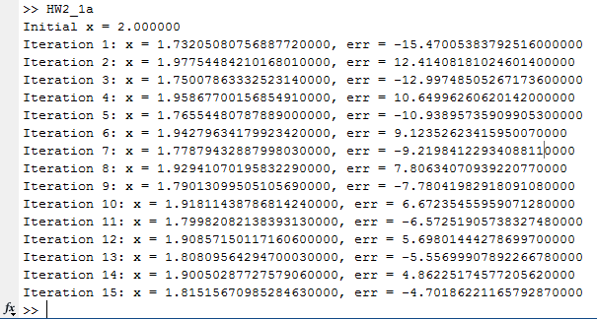

**.**

**.**

**.**

For $g_{3}\left(x\right)= \frac{{(x+10)}^{1/2}}{x}$, equation give a root as 1.85550098207740180000 in 91th step.

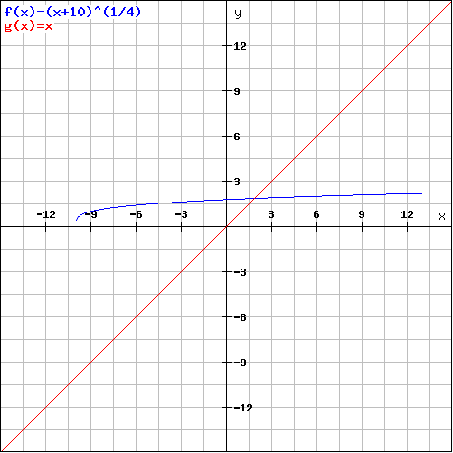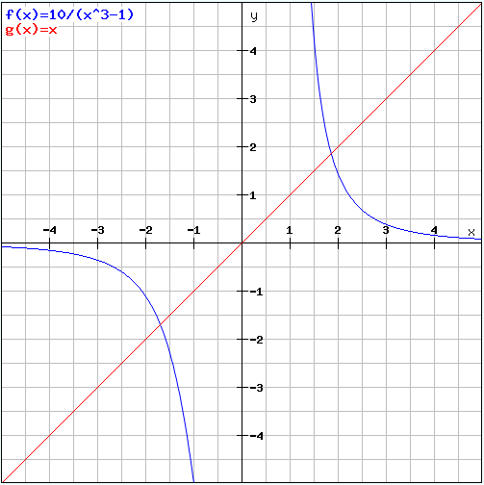**Solution 1.d**

In area **I and II**, $g_{2}(x)$ is a rising curve

$0<{g_{2}}^{'}\left(x\right)< 1$. The iteration converges. It give a root.

In area **I**, $g_{1}(x)$ is a falling curve

${g_{1}}^{'}\left(x\right)< -1$. The iteration diverges. It does not give any root.

In area **III**, $g_{1}(x)$ is a rising curve

${g_{1}}^{'}\left(x\right)>1$. The iteration diverges. It does not give any root.

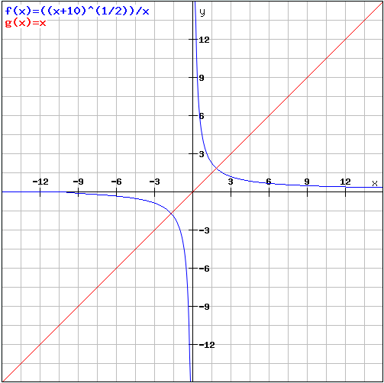

In area **I** intersection of , $g_{3}(x)$ and , $y=x$ give a root same as with another convergence , $g_{2}\left(x\right).$ Finally, $g_{3}(x)$ converge.

**Solution 2**

The matrix that be evaluated is:

$$A= \left[\begin{matrix}10 & 2 & -1 \\ -3 & -6 & 2 \\ 1 & 1 & 5\end{matrix}\right]$$

First, we need to compute $\left[L\right]$ and $\left[U\right]$ matrices. To find upper triangular matrix $\left[U\right]$

* Multiply the first row by $3/{10}$ and add the result to the second tow to eliminate the $a_{21}$ term.
* Then, multiply the first row by ${-1}/{10}$ and add the result to third row to eliminate the $a_{31}$ term. The result is
$\left[\begin{matrix}10 & 2 & -1 \\ 0 & -5.4 & 1.7 \\ 0 & 0.8 & 5.1\end{matrix}\right]$

* Multiply the second row by ${-0.8}/{5.4}=0.148148$ and add the result to third row to eliminate the $a_{32}$ term. Final result for $\left[U\right]$ is like following,
$U= \left[\begin{matrix}10 & 2 & -1 \\ 0 & -5.4 & 1.7 \\ 0 & 0 & 5.351852\end{matrix}\right]$

* To find lower triangular matrix for $\left[A\right]$, can be used coefficients where is found in order to observe $\left[U\right]$. Inverse of blue multipliers will be element for $L_{21 }$, $L_{31 }$, $L_{32 }$ respectively.

$L= \left[\begin{matrix}1 & 0 & 0 \\ -0.3 & 1 & 0 \\ 0.1 & -0.148148 & 0\end{matrix}\right]$

$A=LU= \left[\begin{matrix}1 & 0 & 0 \\ -0.3 & 1 & 0 \\ 0.1 & -0.148148 & 0\end{matrix}\right]\left[\begin{matrix}10 & 2 & -1 \\ 0 & -5.4 & 1.7 \\ 0 & 0 & 5.351852\end{matrix}\right]$

$AA^{-1}=I$, so that

* $L.z=c$, $U.x=z$ is repeated for each column.

The first column of the matrix inverse can be determined by using the

$\left[\begin{matrix}1 & 0 & 0 \\ -0.3 & 1 & 0 \\ 0.1 & -0.148148 & 0\end{matrix}\right] . \left[\begin{matrix}z_{1} \\ z_{2} \\ z_{3}\end{matrix}\right]$ = $\left[\begin{matrix}1 \\ 0 \\ 0\end{matrix}\right]$ and it is solved via forward substitution,

$z$ can be found following $\left[\begin{matrix}z_{1} \\ z_{2} \\ z_{3}\end{matrix}\right]= \left[\begin{matrix}1 \\ 0.3 \\ -0.055556\end{matrix}\right]$. This vector is used as the right-hand side of the upper triangular system, $U.x=z.$

$\left[\begin{matrix}10 & 2 & -1 \\ 0 & -5.4 & 1.7 \\ 0 & 0 & 5.351852\end{matrix}\right] . \left[\begin{matrix}x_{1} \\ x_{2} \\ x_{3}\end{matrix}\right]$ = $\left[\begin{matrix}1 \\ 0.3 \\ -0.055556\end{matrix}\right]$

which can be solved by back substitution and the result will be the first column of the invers matrix $A^{-1}$.

$${[A]}^{-1}= \left[\begin{matrix}0.110727 & ? & ? \\ -0.058824 & ? & ? \\ -0.010381 & ? & ?\end{matrix}\right]$$

To determine the second column,

$\left[\begin{matrix}1 & 0 & 0 \\ -0.3 & 1 & 0 \\ 0.1 & -0.148148 & 0\end{matrix}\right] . \left[\begin{matrix}z_{1} \\ z_{2} \\ z_{3}\end{matrix}\right]$ = $\left[\begin{matrix}0 \\ 1 \\ 0\end{matrix}\right]$ and it is solved via forward substitution,

$z$ can be found following $\left[\begin{matrix}z_{1} \\ z_{2} \\ z_{3}\end{matrix}\right]= \left[\begin{matrix}0 \\ 1 \\ 0.148148\end{matrix}\right]$. And the results are used with $U.x=z$

to determine $[x]$ via back substitution. The second column of the inverse of $A$,

$${[A]}^{-1}= \left[\begin{matrix}0.110727 & 0.038062 & ? \\ -0.058824 & -0.176471 & ? \\ -0.010381 & 0.027682 & ?\end{matrix}\right]$$

Finally, using same steps, third column of the inverse of $A$ can be found like fallowing.

$${[A]}^{-1}= \left[\begin{matrix}0.110727 & 0.038062 & 0.00692 \\ -0.058824 & -0.176471 & 0.058824 \\ -0.010381 & 0.027682 & 0.186851\end{matrix}\right]$$

**Solution 3**

$$Let \left\{σ_{i}, v_{i}\right\}be set of n pairs \left(eigenvalue, eigenvector\right)corresponding A^{T}A.$$

$$The eigenvectors are orthonormal and go into columns of V. r non-zero eigenvalues.$$

$$A^{T}Av_{i}= σ_{i}v_{i}$$

$${\left(Av_{i}\right)}^{ T}\left(Av_{i}\right)= v_{i}^{T}A^{T}Av_{i}= v_{i}^{T}\left(A^{T}Av_{i}\right)= v_{i}^{T}\left(σ_{i}v_{i}\right)= σ_{i}v_{i}^{T}v_{i}= σ_{i}$$

$${\left\|Av_{i}\right\|}^{2}= σ_{i}, σ_{i }≥0$$

$$For the positive σ_{i}, λ_{i}= \sqrt{σ_{i}} and u_{i}=Av_{i}/λ_{i}$$

$$u_{i}^{T}u_{j}=\frac{v_{i}^{T}A^{T}Av_{j}}{λ_{i}λ_{j}}=\frac{σ_{j}v_{i}^{T}v_{j}}{λ_{i}λ_{j}}$$

$$\left(i,j\right) U^{T}AV= u_{i}^{T}Av_{j}$$

$Therefore the only non-zeros in the product U^{T}AV are the first r diagonal entries (which are λ_{1},λ_{2},…λ_{r})$.

$$U^{T}AV= Λ , which means that A=UΛV^{T}$$

**Solution 4**

**“sample.png”** which is 256x256 pixel image corresponds to a 256 by 256 matrix **“imageMatrix”**.

The SVD of $A$ as $A=U∑V^{T}$.

The approximations for various values of k (k = 3, 10, 20, 100) can be shown in MATLAB Code.

r1 = 3;

r2 = 10;

r3 = 20;

r4 = 100;

colormap('gray')

imageMatrix = imread('sample.png');

figure(1)

image(imageMatrix);

imageMatrix = double(imageMatrix);

[U,S,V] = svd(imageMatrix);

figure(2)

colormap('gray')

image(U(:,1:r1)*S(1:r1,1:r1)*V(:,1:r1)')

figure(3)

colormap('gray')

image(U(:,1:r2)*S(1:r2,1:r2)*V(:,1:r2)')

figure(4)

colormap('gray')

image(U(:,1:r3)*S(1:r3,1:r3)*V(:,1:r3)')

figure(5)

colormap('gray')

image(U(:,1:r4)*S(1:r4,1:r4)*V(:,1:r4)')

And corresponding output will be:

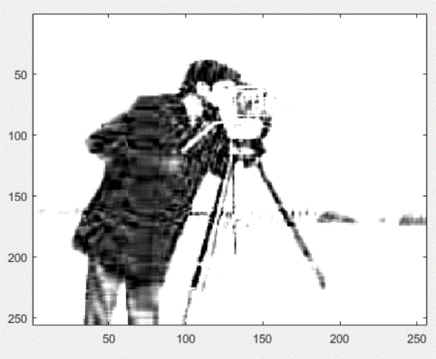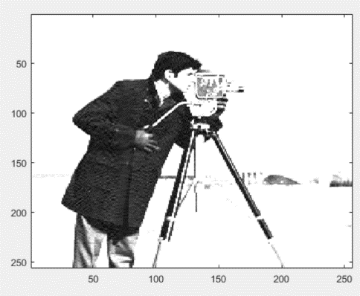

r = 20

r = 100

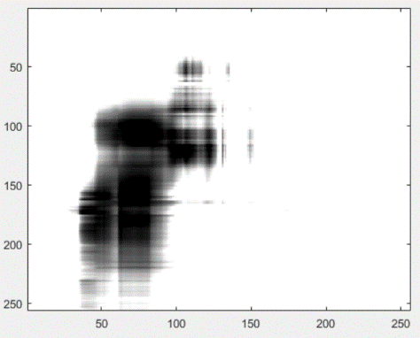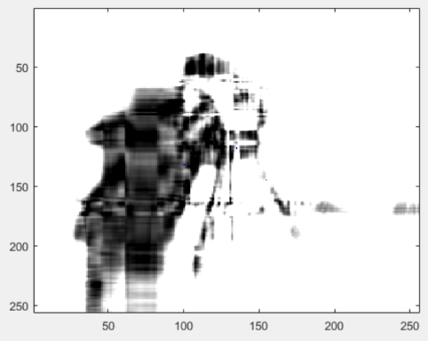

r = 3

r = 10

**Solution 5**

load('A.mat');

A;

AtA = A'*A;

total = sum(AtA(:));

average = total/4;

centeredAtA = AtA - average

M = [1;0]; %%Initial matrix

index = 1;

while index < 10 %%Iterate 10 times

iterationM = centeredAtA * M; %%A*v = v_next

n = norm(iterationM);

iterationM = iterationM / n; %%norm of iteration eigenvector

M = iterationM;

index = index + 1;

end

K = eig(centeredAtA); %%All eigenvalues

eigenValueWithSVD = K(2,1) %%dominant eigenvalue found in SVD

B = centeredAtA*iterationM; %%AX = lamda*X

x = B(1,1);

y = iterationM(1,1);

eigenValueWithPIM = x / y %% dominant eigenvalue found in PIM

%% Both are equal

In MATLAB Code, it can be seen that dominant eigenvalues are equal in found by SVD and PIM.

In power iteration method, initial matrix is $\left[\begin{matrix}1 \\ 0\end{matrix}\right]$.

After the power iteration, dominant eigenvector will be $\left[\begin{matrix}0.5787 \\ -0.8156\end{matrix}\right]$ and corresponding dominant eigenvalue is $498.1708$*.*